Bangladesh Medical Association (BMA)
List of Life Member-129
42. BMA Naogaon Branch

Sl No | Voter No | Voter Details
1 | Voter No  LM-4200001 | DR. MD. ATM SHAHJAHAN ALI  F/Name:  M/Name:  BM & DC Reg. No:  NID:  Cell:  Address: Deputy Civil Surgon  Naogaon  Blood Group:  E X P I R E D
2 | Voter No  LM-4200002  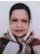 | DR. NAZLE BEGUM  F/Name:  M/Name:  BM & DC Reg. No:  NID:  Cell:  Address: Jr. Consultant (Gyn)  Sador Hospital  Naogaon  Blood Group:
3 | Voter No  LM-4200003  No Image | DR. MASUD ALI DEWAN  F/Name: Late Kashem Ali Dewan  M/Name: Late Sobeda  BM & DC Reg. No: 31549  NID: 6426007165208  Cell: 01712022084  Address: Diabetic samity , Naogaon  Blood Group: AB+  E X P I R E D
4 | Voter No  LM-4200004  No Image | DR. SM AKTHER HOSSAIN  F/Name:  M/Name:  BM & DC Reg. No:  NID:  Cell:  Address: Radiologist, Sador Hospital, Naogaon  Blood Group: AB+  E X P I R E D
5 | Voter No  LM-4200005  No Image | DR. MD. ABDUL KUDDUS  F/Name:  M/Name:  BM & DC Reg. No:  NID:  Cell:  Address: THFP Office  Sador Hospital  Naogaon  Blood Group:
6 | Voter No  LM-4200006  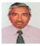 | DR. MD. A K FAZLUL HAQUE  F/Name:  M/Name:  BM & DC Reg. No:  NID:  Cell:  Address: TH & FPO THC  Patnitola, Naogaon.  Blood Group:  E X P I R E D
7 | Voter No  LM-4200007  No Image | DR. HARUN -AR - RASHID  F/Name:  M/Name:  BM & DC Reg. No:  NID:  Cell:  Address: TH & FPO THC  Manda  Naogaon  Blood Group:
8 | Voter No  LM-4200008  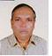 | DR. MD. ASHEK HOSSAIN  F/Name:  M/Name:  BM & DC Reg. No:  NID:  Cell:  Address: TH & FPO THC  Badolgachi  Naogaon  Blood Group:
9 | Voter No  LM-4200009  No Image | DR. KALI KISHORE DAS  F/Name:  M/Name:  BM & DC Reg. No:  NID:  Cell:  Address: M. O. THC  Manda, Naogaon.  Blood Group:
10 | Voter No  LM-4200010  No Image | DR. MD. SHAMSER ALI  F/Name:  M/Name:  BM & DC Reg. No:  NID:  Cell:  Address: Chakenete  Mohadeppur, Naogaon.  Blood Group:
11 | Voter No  LM-4200011  No Image | DR. MD. ELAHI BAKS  F/Name:  M/Name:  BM & DC Reg. No:  NID:  Cell:  Address: TH & FPO THC  Sapohar  Naogaon  Blood Group:  TRANSFERED to BMA Dhaka City  LM-1405543
12 | Voter No  LM-4200012  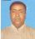 | DR. A. K. SHAMSUDDIN SIDDIQUE  F/Name:  M/Name:  BM & DC Reg. No:  NID:  Cell:  Address: DG, DGHC, Mohakhali, Dhaka  Blood Group:  E X P I R E D
13 | Voter No  LM-4200013  No Image | DR. MD. RUHUL AMIN  F/Name: Md. A Sattar Pk  M/Name:  BM & DC Reg. No:  NID:  Cell:  Address: RMO, Sador Hospital  Madermaized, Naogaon  Blood Group:  E X P I R E D
14 | Voter No  LM-4200014  No Image | DR. SHARIF AHMED  F/Name:  M/Name:  BM & DC Reg. No:  NID:  Cell:  Address: 862, Monipur, 2nd Foor, Mirpur, Section 2, Dhaka 1216  Blood Group:  TRANSFERED to BMA Dhaka City  LM-1405543
15 | Voter No  LM-4200015  No Image | DR. MOST. MERINA AKTER  F/Name: Md. Anisur Rahman  M/Name:  BM & DC Reg. No:  NID:  Cell:  Address: Monda Thana Dispensary  Monda  Naogaon  Blood Group:
16 | Voter No  LM-4200016 | DR. A.S. REZAUL MAHMUD  F/Name: Late Md. Abdus Sattar  M/Name:  BM & DC Reg. No:  NID:  Cell:  Address: Safin Diagnostic Centre  Godown More  Naogaon  Blood Group:
17 | Voter No  LM-4200017 | DR. ABDUR ROB AZAD  F/Name: Md. Rafiq Uddin  M/Name:  BM & DC Reg. No:  NID:  Cell:  Address: Medi Care Pathology  Kazir More  Naogaon  Blood Group:
18 | Voter No  LM-4200018  No Image | DR. M R CHODHURY  F/Name: Moiior Rahman  M/Name:  BM & DC Reg. No:  NID:  Cell:  Address: Ukil Para, Naogaon  Blood Group:  E X P I R E D
19 | Voter No  LM-4200019  No Image | DR. MD. ABDUL GAFFAR  F/Name:  M/Name:  BM & DC Reg. No:  NID:  Cell:  Address: Transfered to BMA Bogra Branch  Blood Group:  TRANSFERED to BMA Dhaka City  LM-1405543
20 | Voter No  LM-4200020 | DR. MD. MOINUL HAQUE  F/Name: Mr. Ahmed Hussain  M/Name:  BM & DC Reg. No:  NID:  Cell:  Address: Ahmed Diag. Centre  Hospital Road  Naogaon  Blood Group:
21 | Voter No  LM-4200021  No Image | DR. A. K. M. SHAHIDUR RAHMAN TARAFDER  F/Name:  M/Name:  BM & DC Reg. No:  NID:  Cell:  Address: TRANSFERED to BMA Rajshahi Branch  LM-96.  Blood Group:  TRANSFERED to BMA Dhaka City  LM-1405543
22 | Voter No  LM-4200022  No Image | DR. SHIRAJEE NAZMUL HASNAIN  F/Name:  M/Name:  BM & DC Reg. No:  NID:  Cell:  Address: Transfered to BMA Chapai Nowabgonj Br. LM-03  Blood Group:  TRANSFERED to BMA Dhaka City  LM-1405543
23 | Voter No  LM-4200023  No Image | DR. MD. HABIBULLAH SARKER  F/Name: Abu Ahmed Altal Ali  M/Name:  BM & DC Reg. No:  NID:  Cell:  Address: M.O. THC  Badolgachi  Naogaon  Blood Group:
24 | Voter No  LM-4200024  No Image | DR. PROBODH KUMAR BISWAS  F/Name:  M/Name:  BM & DC Reg. No:  NID:  Cell:  Address: Tranesfered to Rajshahi.LM-113  Blood Group:  TRANSFERED to BMA Dhaka City  LM-1405543
25 | Voter No  LM-4200025  No Image | DR. K. M. MASUDUR RAHMAN  F/Name:  M/Name:  BM & DC Reg. No:  NID:  Cell:  Address: Transferd to BMA Dhaka City  Blood Group:  TRANSFERED to BMA Dhaka City  LM-1405543
26 | Voter No  LM-4200026 | DR. MD. HABIB NEWAZ HIRU  F/Name: Late Md. Khoda Newaz  M/Name:  BM & DC Reg. No:  NID:  Cell:  Address: Rani Nagor UHC. Naogaon  Blood Group:  E X P I R E D
27 | Voter No  LM-4200027  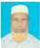 | DR. MD. AMIR UDDIN MONDOL  F/Name: Late Hazi Md. Paran Uddin MONDOL  M/Name:  BM & DC Reg. No:  NID:  Cell:  Address: Mohadebpur  Naogaon  Blood Group:
28 | Voter No  LM-4200028  No Image | DR. A. K. M. SHAMSUL ALAM  F/Name: Md. Ershad Ali  M/Name:  BM & DC Reg. No:  NID:  Cell:  Address: Shirina Clinic, Nagipur  Patnitola  Naogaon  Blood Group:
29 | Voter No  LM-4200029 | DR. MD. AZIZUL HOQUE  F/Name: Md. Ashab Ali Mondol  M/Name:  BM & DC Reg. No:  NID:  Cell:  Address: Cham. Chikitsha Bhaban Main Road  Naogaon  Blood Group:
30 | Voter No  LM-4200030  No Image | DR. MALEKA KHATUN  F/Name: Late Md. Zillur Rahman  M/Name:  BM & DC Reg. No:  NID:  Cell:  Address: Naogoan Nursing Home  Ukil Para, Naogaon.  Blood Group:
31 | Voter No  LM-4200031  No Image | DR. A. K. M. MASUDUR RAHMAN  F/Name:  M/Name:  BM & DC Reg. No:  NID:  Cell:  Address: Transfered to BMA Bogra Branch  Blood Group:  TRANSFERED to BMA Dhaka City  LM-1405543
32 | Voter No  LM-4200032  No Image | DR. MD.ANWAR HOSSAIN  F/Name: Md. Titub Ali Sarkar  M/Name:  BM & DC Reg. No:  NID:  Cell:  Address: Sador Hospital  Naogaon  Blood Group:
33 | Voter No  LM-4200033  No Image | DR. MD. AZIZUL ALAM  F/Name: Md. Mazibar Rahman  M/Name:  BM & DC Reg. No:  NID:  Cell:  Address: Compath Medical Centre  Kazir More  Naogaon  Blood Group:
34 | Voter No  LM-4200034 | DR. MD. HABIBUR RAHMAN  F/Name: Late Sabed Ali  M/Name:  BM & DC Reg. No:  NID:  Cell:  Address: Chalk Enayet  Doyler More  Naogaon  Blood Group:
35 | Voter No  LM-4200035 | DR. MD. MAHBUB ALAM SIDDIQUI  F/Name: Md. Habibur Rahman  M/Name:  BM & DC Reg. No:  NID:  Cell:  Address: Nutun Saha Pur  Santahar  Naogaon  Blood Group:
36 | Voter No  LM-4200036  No Image | DR. KABERI GUH  F/Name:  M/Name:  BM & DC Reg. No:  NID:  Cell:  Address: Tranesfered to Rajshahi Br.LM-114.  Blood Group:  TRANSFERED to BMA Dhaka City  LM-1405543
37 | Voter No  LM-4200037  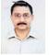 | DR. A. H. MAHMUD SIDDIQUEY  F/Name: Abdus Sattar Siddique  M/Name:  BM & DC Reg. No:  NID:  Cell:  Address: Ukil Para  Naogaon  Blood Group:
38 | Voter No  LM-4200038 | DR. MD. ESKENDER HOSSAIN  F/Name: Md. Abdus Samad Sarkar  M/Name:  BM & DC Reg. No:  NID:  Cell:  Address: Bihary Colony  Bangabaria  Naogaon  Blood Group:
39 | Voter No  LM-4200039  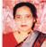 | DR. RAUSHAN ARA KHAN  F/Name:  M/Name:  BM & DC Reg. No:  NID:  Cell:  Address: Medical Officer  Upazila Health Complex  Naogaon  Blood Group:
40 | Voter No  LM-4200040  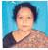 | DR. SHIRIN AKHTER  F/Name: Md. Romzan Ali  M/Name:  BM & DC Reg. No:  NID:  Cell:  Address: Chalk Enayet  Doyler More  Naogaon  Blood Group:
41 | Voter No  LM-4200041  No Image | DR. MD. ZIAUL HAQUE  F/Name: Late Jalilur Rahman  M/Name:  BM & DC Reg. No:  NID:  Cell:  Address: Rahman Diag. Centre, Chalk Enayet  Doyler More  Naogaon  Blood Group:
42 | Voter No  LM-4200042 | DR. MD. MOYEEN UDDIN  F/Name: Late Rustom Ali Mondal  M/Name:  BM & DC Reg. No:  NID:  Cell:  Address: Alrazi Eye Care Komaigari  Naogaon  Blood Group:
43 | Voter No  LM-4200043  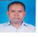 | DR. MIRZA MD. MUKTADIR BILLAH  F/Name:  M/Name:  BM & DC Reg. No:  NID:  Cell:  Address: Raj Clinic  Naogaon  Blood Group:
44 | Voter No  LM-4200044 | DR. MD. FAZLUR RAHMAN  F/Name:  M/Name:  BM & DC Reg. No:  NID:  Cell:  Address: UP & FPO  Raninagar  Naogaon  Blood Group:
45 | Voter No  LM-4200045  No Image | DR. KHAIRUL ALAM CHOUDHURY  F/Name: Late Hafiz Uddin Choudhury  M/Name:  BM & DC Reg. No:  NID:  Cell:  Address: Upazila Health Complex  Sapahar  Naogaon  Blood Group:
46 | Voter No  LM-4200046 | DR. MD. MAHFUZAR RAHMAN  F/Name: Khondker Md. Khalilur Rahman  M/Name:  BM & DC Reg. No:  NID:  Cell:  Address: Chakenayet Hospital Road  Naogaon  Blood Group:
47 | Voter No  LM-4200047  No Image | DR. MD. MOMINUL HAQUE  F/Name: Md. Dayem  M/Name:  BM & DC Reg. No:  NID:  Cell:  Address: Khas Naogaon  Naogaon  Blood Group:
48 | Voter No  LM-4200048  No Image | DR. A.H.M. IZAHARUL ISLAM  F/Name: Md. Sirajul Islam  M/Name:  BM & DC Reg. No:  NID:  Cell:  Address: Upazila Health Complex  Patnitola  Naogaon  Blood Group:
49 | Voter No  LM-4200049  No Image | DR. MD. ABU OBAID  F/Name: Late Alhaj Kamejuddin  M/Name:  BM & DC Reg. No:  NID:  Cell:  Address: Nazipur  Naogaon  Blood Group:
50 | Voter No  LM-4200050  No Image | DR. MD. ISTIAQC CHOUDHURY  F/Name: Late Easrshad Ali Choudhury  M/Name:  BM & DC Reg. No:  NID:  Cell:  Address: Ukil Para, Naogaon  Blood Group:  E X P I R E D
51 | Voter No  LM-4200051 | DR. MD. EMDADUL HAQUE  F/Name: Late Ayez Uddin Mondol  M/Name:  BM & DC Reg. No:  NID:  Cell:  Address: Per. Naogaon (Stadium Para)  Naogaon  Blood Group:
52 | Voter No  LM-4200052  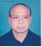 | DR. MD. MOZAMMEL HAQUE  F/Name: Late Tayeb Ali Mondal  M/Name:  BM & DC Reg. No:  NID:  Cell:  Address: M.O. Naogaon Sadar Hospital  Naogaon  Blood Group:
53 | Voter No  LM-4200053  No Image | DR. SULTANA AFROZ  F/Name: Md. Altaf Hossain  M/Name:  BM & DC Reg. No:  NID:  Cell:  Address: M.O. Naogaon Sadar Hospital  Naogaon  Blood Group:
54 | Voter No  LM-4200054 | DR. MD. ZAHID NAZRUL CHOWDHURY  F/Name: Late Nazrul Islam Chowdhury  M/Name:  BM & DC Reg. No:  NID:  Cell:  Address: F/39, Ukil Para  Naogaon  Blood Group:
55 | Voter No  LM-4200055 | DR. AFM. NURUZZAMAN MUNSHI  F/Name: Alhaj Md. Khodaboksha Monshi  M/Name:  BM & DC Reg. No:  NID:  Cell:  Address: UH & FPO, Raninajar Health Complex  Poraninajar  Naogaon  Blood Group:
56 | Voter No  LM-4200056  No Image | DR. MD. A. MOTTALAB HOSSAIN  F/Name:  M/Name:  BM & DC Reg. No:  NID:  Cell:  Address: Associate Professor & Head of Dept. Shaheed Ziaur Rahman Medical College Hospital, Bogra.  Blood Group:  TRANSFERED to BMA Dhaka City  LM-1405543
57 | Voter No  LM-4200057  No Image | DR. MD. ABDUS SOBHAN  F/Name:  M/Name:  BM & DC Reg. No:  NID:  Cell:  Address: Consultant Surgeon  Sadar Hospital, Naogaon  Blood Group:  TRANSFERED to BMA Dhaka City  LM-1405543
58 | Voter No  LM-4200058  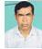 | DR. AKM. ABU HASAN  F/Name: Md. Wahed Hossain  M/Name:  BM & DC Reg. No:  NID:  Cell:  Address: Saya Nir  Kalitola  Naogaon  Blood Group:
59 | Voter No  LM-4200059 | DR. ANJUMAN ARA  F/Name: Dr. Asgar Ali Talukder  M/Name:  BM & DC Reg. No:  NID:  Cell:  Address: Medical Officer  Naogaon Sadar Hospital  Naogaon  Blood Group:
60 | Voter No  LM-4200060  No Image | DR. FARZANA SOHAEL  F/Name:  M/Name:  BM & DC Reg. No:  NID:  Cell:  Address: Consultant Gynae & OBS  Naogaon Sadar, Naogaon  Blood Group:  TRANSFERED to BMA Dhaka City  LM-1405543
61 | Voter No  LM-4200061  No Image | DR. MD. ARIFUR RAHMAN  F/Name:  M/Name:  BM & DC Reg. No:  NID:  Cell:  Address: Consultant Cardiology  Sadar Hospital, Naogaon  Blood Group:  TRANSFERED to BMA Dhaka City  LM-1405543
62 | Voter No  LM-4200062 | DR. PROSENJIT SANYAL  F/Name: Mohonlal Sanyal  M/Name:  BM & DC Reg. No:  NID:  Cell:  Address: Wapda Gate  Kanthaltoli, Naogaon  Blood Group:
63 | Voter No  LM-4200063 | DR. MD. MUKTAR HOSSAIN  F/Name: Md. Mozahar Hossain  M/Name:  BM & DC Reg. No: 26028  NID:  Cell: 01715673036  Address: Morakati Road  Khash Naogaon  Naogaon  Blood Group:
64 | Voter No  LM-4200064 | DR. MOST. NAZMA SULTANA  F/Name: Mofiz Uddin Ahmed  M/Name:  BM & DC Reg. No:  NID:  Cell:  Address: Morakati Road  Khash Naogaon  Naogaon  Blood Group:
65 | Voter No  LM-4200065 | DR. SM. NAZMUL HASAN  F/Name: SM. Enamul Haque  M/Name:  BM & DC Reg. No:  NID:  Cell:  Address: Medical Officer  Sadar Hospital  Naogaon  Blood Group:
66 | Voter No  LM-4200066  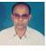 | DR. RATON KUMAR SINGH  F/Name:  M/Name:  BM & DC Reg. No:  NID:  Cell:  Address: Medical Officer  Civil Surgeon Officer  Naogaon  Blood Group:
67 | Voter No  LM-4200067 | DR. MD. MASUD ALI DEWAN  F/Name: Late Kashem Ali Dewan  M/Name:  BM & DC Reg. No:  NID:  Cell:  Address: Samity Hospital  Naogaon.  Blood Group:
68 | Voter No  LM-4200068 | DR. MD. ABDUL BARI KANDAKAR  F/Name: Abdul Gafur Khandakar  M/Name:  BM & DC Reg. No:  NID:  Cell:  Address: H-3798, Ukil Para,  Naogaon  Blood Group:
69 | Voter No  LM-4200069  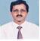 | DR. MD. KAMRUL AHSAN  F/Name: Md. Ibrahim Khalil  M/Name:  BM & DC Reg. No:  NID:  Cell:  Address: A/15, Aparajeeta, Bangabaria,  Naogao  Blood Group:
70 | Voter No  LM-4200070  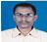 | DR. MD. MAMUNAL HAQUE  F/Name: Late Mazannel Haque  M/Name:  BM & DC Reg. No:  NID:  Cell:  Address: Naogaon Sadar,  Naogaon.  Blood Group:
71 | Voter No  LM-4200071 | DR. SHARMINA JALIL  F/Name: Md. Abdul Jalil  M/Name:  BM & DC Reg. No:  NID:  Cell:  Address: Foyezvilla, Chokdeb,  Naogaon.  Blood Group:
72 | Voter No  LM-4200072  No Image | DR. NOOR MOHAMMAD NOORU  F/Name: Late. Riaz Uddin  M/Name:  BM & DC Reg. No:  NID:  Cell:  Address: Sapahar Clinic,  Upazila Sapahar, Naogaon.  Blood Group:
73 | Voter No  LM-4200073  No Image | DR. MD. SHAMSUDDIN MONDOL  F/Name: : Late Monir Uddin Mondol  M/Name:  BM & DC Reg. No:  NID:  Cell:  Address: Jamuna Clinic Bhaban, Santahar Road,  Par-Naigaon, Naogaon.  Blood Group:
74 | Voter No  LM-4200074  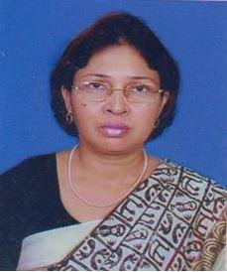 | DR. ROUNAK JAHAN  F/Name: Dr. Md. Moslem Ali  M/Name:  BM & DC Reg. No: 17739  NID:  Cell:  Address: Sarkar Home, D-48,  Chokmokter, Naogaon.  Blood Group:
75 | Voter No  LM-4200075  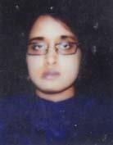 | DR. MOUMITA JALIL  F/Name: Md. Abdul Jalil (Mp)  M/Name: Mrs. Jesmina Jalil  BM & DC Reg. No: 43366  NID: 2695042759745  Cell: 01711191199  Address: C/O Md, Abdul Jalil (MP), Foyej Villa, Chalkdeb, Naogaon.  Blood Group: B+
76 | Voter No  LM-4200076  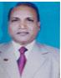 | DR. ANANDA MOHAN MONDOL  F/Name: Marendra Nath Mondol  M/Name: Madhaby Mondol  BM & DC Reg. No: A-14768  NID:  Cell:  Address: Medical Officeer (Mch-Fp)Uhc Porsha Naogaon  Blood Group:
77 | Voter No  LM-4200077  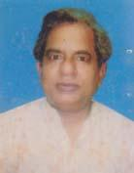 | DR. RANJAN KUMAR KHAN  F/Name: Late Naredra Nath Khan  M/Name: Late Binapani Khan  BM & DC Reg. No: 12973  NID: 410621648680  Cell: 01732366373  Address: Vill: Badalgaehi, P.O: Badalgachi, P.S: Badalgachi, Dt: Naogaon.  Blood Group: A+
78 | Voter No  LM-4200078  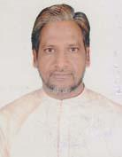 | DR. MD. ABDUS SALAM  F/Name: Late Asaduzzaman  M/Name: Late Jakera Khatun  BM & DC Reg. No: 13229  NID: 0192226332818  Cell: 01711440018  Address: Upazilla Health Complex, Atrai, Naogaon.  Blood Group: B+
79 | Voter No  LM-4200079  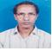 | DR. AHMED HUSSAIN KHAN  F/Name: Mr. Abed Ali Khan  M/Name: Mrs. Anwara Begum  BM & DC Reg. No: A-9854  NID:  Cell:  Address: Chakdew(Daktarpara) Naogaon  Blood Group:
80 | Voter No  LM-4200080 | DR. FARHANA AKTER FARUQUE  F/Name: Dr. Solaiman Al Faruque  M/Name: Kibria Akter  BM & DC Reg. No: 49203  NID: 8198510364374  Cell: 01717671826  Address: Vill: Ukilpara, Post: Naogaon, P.S: Naogaon, Dist: Naogaon.  Blood Group: O+
81 | Voter No  LM-4200081  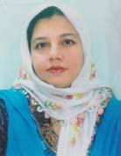 | DR. FATEMA KAMRUN NAHER  F/Name: Late Ashraf Uddin  M/Name: Anowara Begum  BM & DC Reg. No: 23126  NID: 6426001108485  Cell: 01711235082  Address: Bangabaria, North Sadar Hospital, Naogaon.  Blood Group: B+
82 | Voter No  LM-4200082  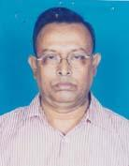 | DR. MD. ABDUL BARI  F/Name:  M/Name:  BM & DC Reg. No: 16698  NID: 6426002116962  Cell:  Address: Bangabaria, Naogaon.  Blood Group: A+  TRANSFERED to BMA Dhaka City  LM-1405543
83 | Voter No  LM-4200083  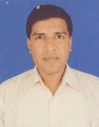 | DR. M.H.M MAHFUZUL ALAM  F/Name: Late Momtaz Hossain  M/Name: Jamila Khatun  BM & DC Reg. No: 18067  NID: 6426001108486  Cell: 01711894741  Address: Bangabaria, Sadar Hospital Road, Naogaon.  Blood Group: O+
84 | Voter No  LM-4200084  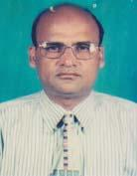 | DR. MUHAMMAD ABDUL JABBAR  F/Name: Late Parash Uddin Mondal  M/Name: Late Mirjan Bewa  BM & DC Reg. No: 12971  NID: 1022001002135  Cell: 01712233574  Address: Upazilla Health & Family Planning Officer, Mohadevpur, Naogaon.  Blood Group: B+
85 | Voter No  LM-4200085 | DR. BIBEKA NONDO GHOSH  F/Name: Birendra Nath Ghosh  M/Name: Sabita Rani Ghosh  BM & DC Reg. No: 39015  NID: 6415066659295  Cell: 01717983255  Address: Vill: Mohadebpur, P.O & P.S: Mohadebpur, Dist: Naogaon.  Blood Group: B+
86 | Voter No  LM-4200086  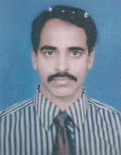 | DR. A.M. AKHTARUZZAMAN  F/Name: Late Jasim Uddin Akhando  M/Name: Late Aleya Begum  BM & DC Reg. No: 24560  NID: 6415015111466  Cell: 01716031111  Address: UHC, Momadebpur, Naogaon.  Blood Group: O+
87 | Voter No  LM-4200087  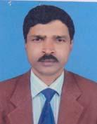 | DR. BIVASH CHANDRA MANI  F/Name: Late Krishna Gopal Mani  M/Name: Radha Rani  BM & DC Reg. No: 15529  NID: 6426005150884  Cell: 01715587888  Address: U.H & F.P.O Sapahar UHC, Naogaon.  Blood Group: A+
88 | Voter No  LM-4200088  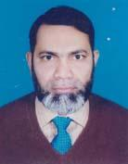 | DR. MD. ASAHAQUE ALI AKNDA  F/Name: Reazuddin Aknda  M/Name: Asia Begum  BM & DC Reg. No: 17773  NID: 6426003128257  Cell: 01711956024  Address: Chalkdeb, Tarafder Para, Naogaon.  Blood Group: A+
89 | Voter No  LM-4200089  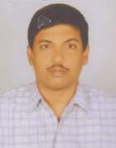 | DR. KAZI MIZANUR RAHMAN  F/Name: Quazi Motaher Hossain  M/Name: Kazi Jahanara Begum  BM & DC Reg. No: 20986  NID: 6426004137401  Cell: 01819479770  Address: Medical Officer (Disease Control) Civil Surgeon,Naogaon.  Blood Group: A+
90 | Voter No  LM-4200090  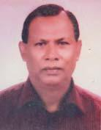 | DR. MD. SHAJEDUR RAHMAN  F/Name: Late Tamiz Uddin Ahmed  M/Name: Late Altafon Nesa  BM & DC Reg. No: 13775  NID: 8198507228300  Cell: 01711578033  Address: R.M.O. UHC Dhawalihat, Naogaon.  Blood Group: O+
91 | Voter No  LM-4200091  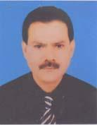 | DR. MD. ABU HENA  F/Name: Late Mahbub Ali Tarafder  M/Name: Late Hamida Khatun  BM & DC Reg. No: 12895  NID:  Cell: 01711436549  Address: Sodar Hospital, Naogaon.  Blood Group:
92 | Voter No  LM-4200092  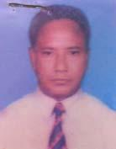 | DR. MD. SOLAIMAN AL FARUQUE  F/Name: Late Tarif Uddin  M/Name: Late Shaleha Khatun  BM & DC Reg. No: 9198  NID: 6426001107985  Cell: 01711302993  Address: Ukilpara, Naogaon.  Blood Group: O+
93 | Voter No  LM-4200093  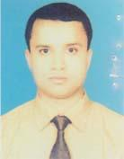 | DR.MOHAMMAD AFTAB RASSEL  F/Name: Mohammad Abdur Razzaque  M/Name: Mrs. Afroza Begum  BM & DC Reg. No: 48244  NID: 8524904042863  Cell: 01816914635  Address: Atrai Upazilla Health Complex Campus Atrai, Naogaon.  Blood Group: B+
94 | Voter No  LM-4200094  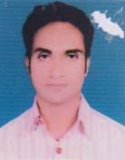 | DR. K.H.M. IFTEKHARUL ALAM KHAN  F/Name: Late Asadul Alam Khan  M/Name: Nazma Khan  BM & DC Reg. No: 35208  NID: 2690243832450  Cell: 01742255197  Address: Upazilla Health Complex Raninagar, Naogaon.  Blood Group: B+
95 | Voter No  LM-4200095  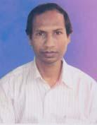 | DR. SWAPAN KUMAR HALDER  F/Name: Late Harendra Nath Halder  M/Name: Late Fulkumari Halder  BM & DC Reg. No: 19342  NID: 6426002113885  Cell: 01711187328  Address: Sadar Hospital Road, Post & Dist: Naogaon, Bangladesh.  Blood Group: O+
96 | Voter No  LM-4200096  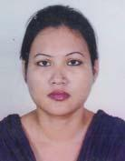 | DR. FARHANA BEGUM  F/Name: Md. Abu Noman  M/Name: Shamsun Nahar  BM & DC Reg. No: 50665  NID: 19841022004036771  Cell: 01918677422  Address: Iqbal Villa, Eidgahpara, Par. Naogaon, Naogaon-6500.  Blood Group: B+
97 | Voter No  LM-4200097  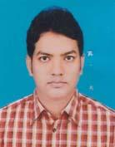 | DR. MD. ZALAL UDDIN  F/Name: Md. Amir Uddin  M/Name: Mrs. Joynab Begum  BM & DC Reg. No: 43597  NID: 2696829754805  Cell: 01712111420  Address: Asst. Surgeon, Prosadpur Union Sub Centre, Manda, Naogaon.  Blood Group: O+
98 | Voter No  LM-4200098  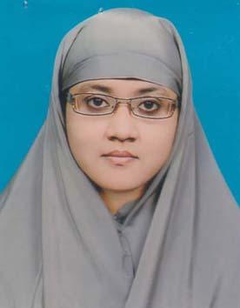 | DR. RUBY AKTER  F/Name: Md. Abdur Razzak  M/Name: Mrs. Jamila Begum  BM & DC Reg. No: 52782  NID: 19842691649423518  Cell: 01915164387  Address: Vill & P.O & P.S: Mohadebpur, Dist: Naogaon.  Blood Group: O+
99 | Voter No  LM-4200099  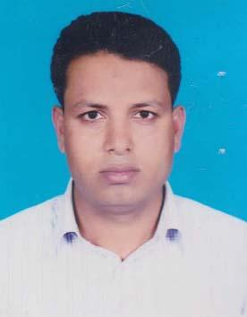 | DR. MD. SAIFUL ISLAM  F/Name: Md. Samser Ali  M/Name: Nurun Nahar  BM & DC Reg. No: 42156  NID: 2696352215145  Cell: 01815911888  Address: Chakmukti D.P. Para, Post & Thana & Dist: Naogaon.  Blood Group: B+
100 | Voter No  LM-4200100  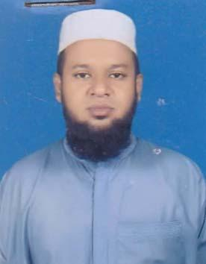 | DR. AL MUKSIT MD. TAUFIQUR RAHAMN  F/Name: Md. Abdur Rahman  M/Name: Mrs. Sirin Akter  BM & DC Reg. No: 34975  NID: 6426004139574  Cell: 01718310577  Address: M.O Sodor Hospital, Naogaon.  Blood Group: A+
101 | Voter No  LM-4200101  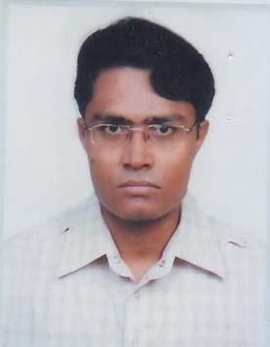 | DR. MD SOHRAB HOSSAIN  F/Name: A.k. Mohammad Ali  M/Name: Sehely Ferdous  BM & DC Reg. No: 43432  NID: 2695047006484  Cell: 01712065281  Address: UHC, Badalgachi, Naogaon.  Blood Group: A+
102 | Voter No  LM-4200102  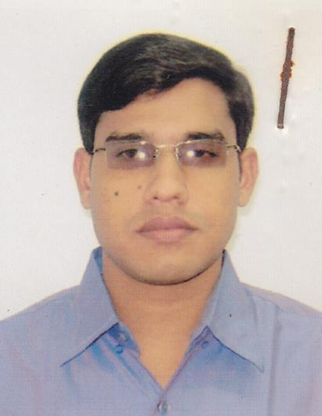 | DR. MD. NAZRUL ISLAM MONDAL  F/Name: Late. Md. Taser Ali Mondal  M/Name: Most. Firoza Begum  BM & DC Reg. No: 48058  NID: 8524904042982  Cell: 01822895845  Address: Vill: Durgapur, P.O. : Mainam,  P.S. : Manda, Dist : Naogaon.  Blood Group: O+
103 | Voter No  LM-4200103  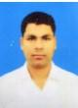 | DR. MD. KHURSHID ALAM  F/Name: Md. Haidar Ali  M/Name: Most. Khaleda Khatun  BM & DC Reg. No: 65402  NID: 8524904189465  Cell: 01723524362  Address: Medical officer, UHC, Porsha, Naogaon  Blood Group: O+
104 | Voter No  LM-4200104  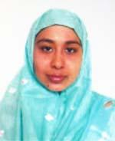 | DR. MST. AYESHA KHATUN  F/Name: Shah Mamun Ar Rashid  M/Name: Mst. Jobeda Jahan  BM & DC Reg. No: 60507  NID: 2716469409661  Cell: 01816915505  Address: Medical officer, UHC, Porsha, Naogaon  Blood Group: O+
105 | Voter No  LM-4200105  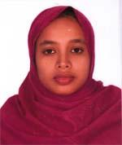 | MST. FARHANA SHIRIN  F/Name: Khandakar Abdul Aziz  M/Name: Mst. Hyatunnessa  BM & DC Reg. No: 46113  NID: 8127204407428  Cell: 01727318184  Address: Vill-Chawapur, Post-Ramgaon, Thana-Manda, Dist-Naogaon  Blood Group: AB+
106 | Voter No  LM-4200106  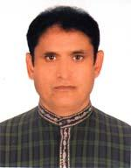 | DR. EKRAMUL BARI TIPU  F/Name: Late Mofiz Uddin Molla  M/Name: Late Khadija Begum  BM & DC Reg. No: 21965  NID: 6414740948780  Cell: 01715122129  Address: Prosadpur Bazar, Manda, Naogaon  Blood Group: A+
107 | Voter No  LM-4200107  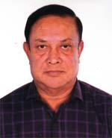 | DR. A. K. M. MOZAHER HOSSAIN  F/Name: Late Ashraf Ali Mondol  M/Name: Shara Banu  BM & DC Reg. No: 13785  NID: 8192214109871  Cell: 01711578378  Address: Civil Surgeon Office Campus, Naogaon  Blood Group: B+
108 | Voter No  LM-4200108  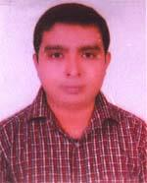 | DR. MD. FAISAL NAHID PABITRA  F/Name: Md. Azizur Rahman  M/Name: Ferdous Nahid Khanum  BM & DC Reg. No: 60899  NID: 8128205574727  Cell: 01712499551  Address: Dakbanglo Road, Post+P.s-Niamatpur, Dist-Naogaon  Blood Group: B+
109 | Voter No  LM-4200109  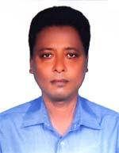 | DR. MD. AKHWANUR RAHMAN CHOWDHURY  F/Name: Md. Mokhlesur Rahman Chowdhury  M/Name: Mrs. Sharifatun Nesa Chowdhury  BM & DC Reg. No: 28488  NID: 3824708138879  Cell: 01717673132  Address: Junior Consultant, Cardiology, Adhunik District Sadar Hospital, Naogaon  Blood Group: A+
110 | Voter No  LM-4200110 | DR. MD. RASHEDUL HAQUE  F/Name: Aftab Uddin Ahmed  M/Name: Sofeda Begum  BM & DC Reg. No: 52371  NID: 6410652006093  Cell: 01717676482  Address: Doctors Dormitong, Upazilla Health Complex, Badalgachi, Naogaon  Blood Group: B+
111 | Voter No  LM-4200111  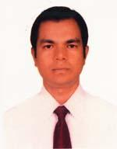 | DR. A. H. M. AHSANUZZAMAN  F/Name: Md. Nuruzzaman  M/Name: Aleya Rahman  BM & DC Reg. No: 57454  NID: 8198510364698  Cell: 01748995668  Address: Ultimate Master Tower, Master Para, Naogaon Sadar, Naogaon  Blood Group: A+
112 | Voter No  LM-4200112  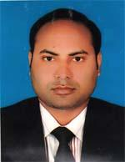 | DR. BIJOY KUMAR RAY  F/Name: Brichitra Bikash Ray  M/Name: Jamuna Rani Ray  BM & DC Reg. No: 61064  NID: 4798516214675  Cell: 01710126513  Address: Old Bus Stand, Naogaon  Blood Group: B+
113 | Voter No  LM-4200113  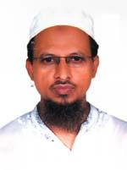 | DR. MD. SHOFE ULLAH  F/Name: Late Noor Mohammad  M/Name: Halima Begum  BM & DC Reg. No: 28666  NID: 6426002112967  Cell: 01711981880  Address: Doctors Lab & Medical Services, Hosspital Road, Naogaon  Blood Group: B+
114 | Voter No  LM-4200114  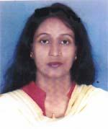 | DR. MST. DILRAJ BANU  F/Name: Late Daraj Uddin  M/Name: Mst. Shamsun Nahar  BM & DC Reg. No: 34853  NID: 19756417551000002  Cell: 01726444044  Address: Naogaon Sadar Hospital  Blood Group: O+
115 | Voter No  LM-4200115 | DR. ADNAN AL FARUQUE  F/Name: Dr. Md. Solaiman Al Faruque  M/Name: Kibria Akhter Banu  BM & DC Reg. No: 65978  NID: 6426001107987  Cell: 01790628788  Address: Vill-Ukilpara, Post-Naogaon, P.s-Naogaon, Dist-Naogaon  Blood Group: O+
116 | Voter No  LM-4200116  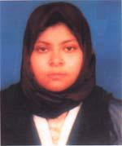 | DR. SHAMMAM FAYEKA  F/Name: Md. Anwar Alam Khan  M/Name: Parveen Akhter Khan  BM & DC Reg. No: 54233  NID: 19879196203120704  Cell: 01717908497  Address: Ukilpara, Naogaon Sadar, Naogaon  Blood Group: A+
117 | Voter No  LM-4200117  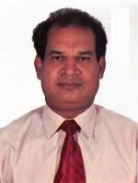 | DR. PRADIP CHANDRA PRAMANIK  F/Name: Pravash Chandra Pramanik  M/Name: Uma Rani Pramanik  BM & DC Reg. No: 22445  NID: 6426002113212  Cell: 01711006145  Address: Ukil- Para, Naogaon  Blood Group: A+
118 | Voter No  LM-4200118  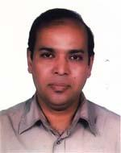 | DR. MD. ARSHAD HOSSAIN  F/Name: Md. Moazzem Hossain  M/Name: Rahima Begum  BM & DC Reg. No: 20168  NID: 7625509166947  Cell: 01714225315  Address: Bangabaria, Sadar Hospital Road, Naogaon  Blood Group: A+
119 | Voter No  LM-4200119  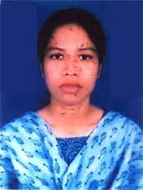 | DR. JANNATUN NAIM  F/Name: A. B. M. Ferdous Habib Bulbul  M/Name: Anjuman Ara  BM & DC Reg. No: 37369  NID: 6426001102266  Cell: 01754531194  Address: Vill-Komaigari, Post+Thana+Dist-Naogaon  Blood Group: B+
120 | Voter No  LM-4200120  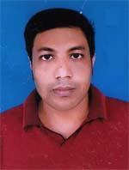 | DR. MD. MAKSHUDUL HAQUE  F/Name: Md. Mozommel Haque  M/Name: Mst. Laila Arjumand Banu  BM & DC Reg. No: 44348  NID: 6426004133922  Cell: 01712931200  Address: Chalkelam, Post & P.s-Naogaon, Dist-Naogaon  Blood Group: O+
121 | Voter No  LM-4200121  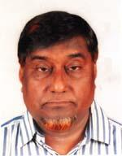 | DR. MD. EMDADUL HUQ  F/Name: Reazuddin Ahmed  M/Name: Zayeda Khatun  BM & DC Reg. No: 10497  NID: 8192214345872  Cell: 01711376026  Address: Senior Consultant Cardiology (RTD) Shafein Diagnostic Centre, A-Team Field, Naogaon  Blood Group: O+
122 | Voter No  LM-4200122  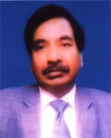 | DR. MD. ALAUDDIN  F/Name: Late Niazuddin Mondol  M/Name: Late Morium Nesa  BM & DC Reg. No: 11286  NID: 6427509371974  Cell: 01712226737  Address: Vill-Chadpur, Upazilla-Patritala, Naogaon  Blood Group: O+
123 | Voter No  LM-4200123 | DR. MD. RUHUL AMIN  F/Name: Md. Abdul Jabbar  M/Name: Mrs. Rabeya Basshirah  BM & DC Reg. No: 42846  NID: 1594116383786  Cell: 01817751763  Address: Madrasha Para, Nazipur, Pataitala, Naogaon  Blood Group: A+
124 | Voter No  LM-4200124  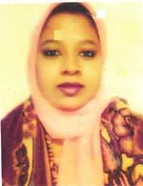 | DR. MST. MANZUDA KHATUN  F/Name: Md. Amzad Hossain  M/Name: Mst. Minara Begum  BM & DC Reg. No: 56224  NID: 1010681044525  Cell: 01753925798  Address: Chalkenet, Doaler More, Naogaon  Blood Group: B+
125 | Voter No  LM-4200125  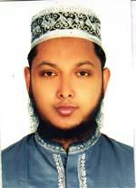 | DR. MD. ABU JAR GAFFAR  F/Name: Md. Mojaffar Hossain  M/Name: Mrs. Rasheda Hossain  BM & DC Reg. No: 41360  NID: 6410621842072  Cell: 01716597339  Address: Kajir Mor, Naogaon  Blood Group: B+
126 | Voter No  LM-4200126  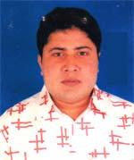 | DR. MD. RUHUL AMIN  F/Name: Md. Nurul Amin  M/Name: Selina Banoo  BM & DC Reg. No: 49175  NID: 19846426004136518  Cell: 01712787814  Address: UHC, Badalgachi, Naogaon  Blood Group: O+
127 | Voter No  LM-4200127  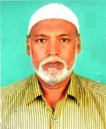 | DR. MD. TAHMIDUR RAHMAN  F/Name: Late Tasir Uddin  M/Name: Late Shahara Khatun  BM & DC Reg. No: 17499  NID: 6426005143397  Cell: 01710873812  Address: MO (MCH/FP) UHC, Badalgachi, Naogaon  Blood Group: B+
128 | Voter No  LM-4200128  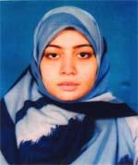 | DR. SHAMEEMA SULTANA  F/Name: A. K. M. Shamsul Alam  M/Name: Mst. Nasima Alam  BM & DC Reg. No: 58171  NID: 8198510364050  Cell: 01744422574  Address: Nasima Villa, Hat Naogaon, Naogaon  Blood Group: B+
129 | Voter No  LM-4200129  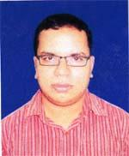 | DR. A. H. M. MOSTOFA KAMAL  F/Name: Md. Shamsuddin Mondal  M/Name: Shahin Parvin  BM & DC Reg. No: 60769  NID: 8198510364540  Cell: 01758434272  Address: Medical officer, UHC, Porsha, Naogaon  Blood Group: O+

